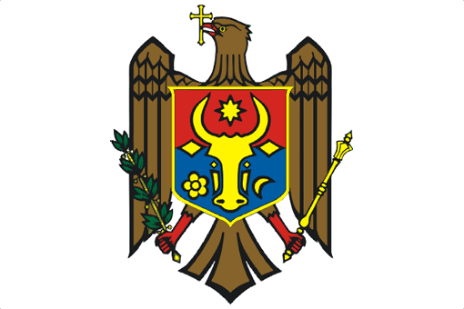

PERMANENT MISSION OF THE REPUBLIC OF MOLDOVA

UPR Working Group
23^{3d} Session
Universal Periodic Review of the Lebanese Republic

Statement of the Delegation of the Republic of Moldova
Delivered by H.E. Victor Moraru, Ambassador, Permanent Representative

(Geneva, 2 November 2015)

Mr. President,

Allow me to welcome the distinguished Lebanese delegation to the UPR Working Group and to thank the head of the delegation for the presentation of the National Report.

The Republic of Moldova commends the Lebanese efforts since the first review to improve the human rights situation in the country, while recognizing that certain reforms have yet to be completed.

We welcome, in particular, the adoption of a National Human Rights Action Plan and of efforts towards the establishment of an independent national human rights institution that will also provide for a mechanism to perform functions required by OP-CAT.

In this regard, we would be interested to learn more about the content and time frame for enactment of these Laws.

We commend the steps taken to combat human trafficking, inter alia, by adopting a Law on the punishment of the crime of trafficking in persons. In order to further strengthen actions in this area, we recommend the Lebanese Republic to adopt a National Action Plan on preventing and combating trafficking in human beings and pursue measures aimed at preventing trafficking and providing appropriate protection to victims.

I thank you, Mr. President.

